Name: Daniel Vong
Student ID: 100870344

Project plan: Assignment Tracker

For my website I will be making a personal assignment tracker webpage that showcases all assignments I am currently in progress doing or have completed. This website will use mongoDB to store a cloud database of all my assignments with variables such as name, due date, weight of assignment, and what course it’s from.
This website will employ full CRUD implementation and allow me to not only read the database but to also add to it, update entries and delete entries. To prevent unauthorized removal the website will also have authentication operations to ensure only authorized users can modify and remove files.

Currently, for assignment tracking I am using the notes app on my phone to checklist everything but this website should help me and others track their assignments from wherever they are even if they do not have their phone on them.
Current Tracker:
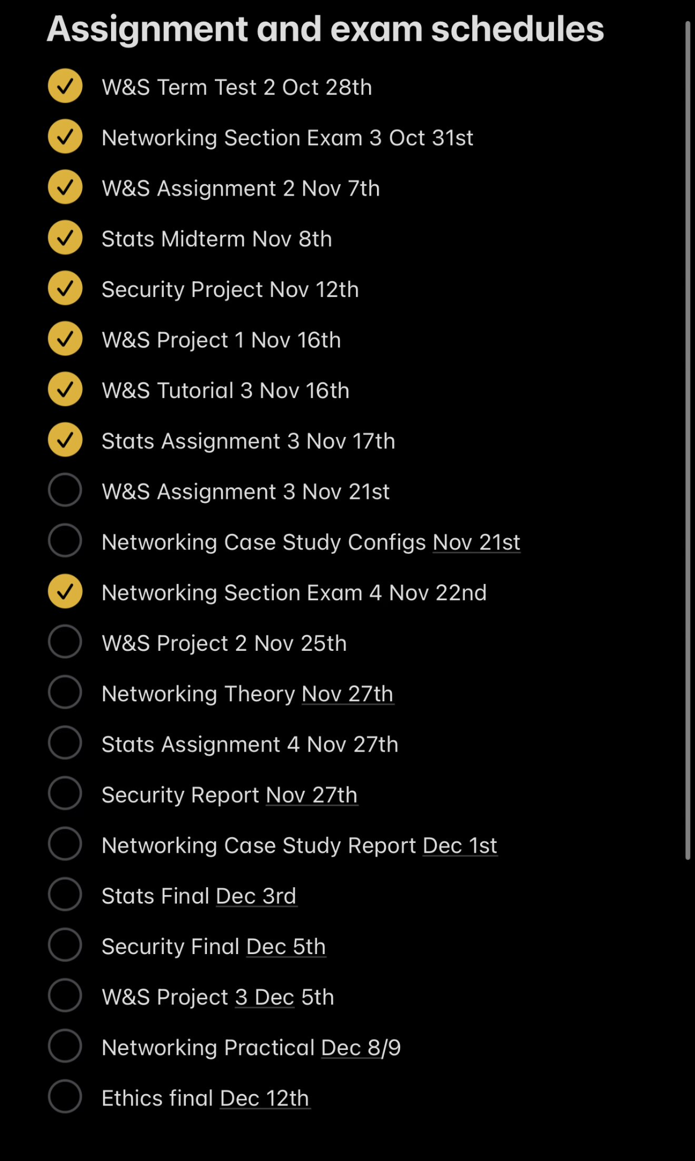
The idea would be to translate this into a website with a proper table to separate the information being displayed; This way, more information on the assignment can be included in the table and stored more neatly with proper separation between each category.

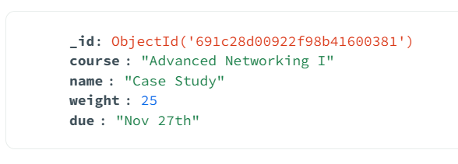Example of an object in this database

